Task 2

DNA

12. 05. 2022
Hradec Králové
Czechia

Preface
To maintain the sustainability of the complex life forms, the continuous metabolic turnover is taking place – including the protein content. There must be an information storage media inside the cell and a way how to use it. Genetics as a scientific discipline dealing with the information and the organismal memory got a solid foundation by Gregor Johann Mendel, born just 200 years ago in small village Hynčice at the Moravian-Silesian border. Since the “Experiments on Plant Hybridization” published by Mendel in 1865 enormous effort was invested to understand the principles of genetics in a very detail, including the genomics, evolutionary genetics, molecular genetics or the link between genes and pathology.
Host-pathogen interactions are important drivers of evolution. These “star wars” escalating sophisticated strategies and contra-strategies on both sides are memorized in our genetic information. Without understanding evolution shaping the particular genome, we can´t understand it´s meaning, because in some aspects it simply does not make sense.
Important pathogens (and extremely important from the evolutionary point of view) are the viruses with the only way how to “survive” – infect the cell and highjack it´s metabolism to copy and amplify the new virions. Luckily, viruses can´t hide 100% from the body security having own proteins (which could be recognized by the immune system) and nucleic acid (RNA or DNA) often with specific marks we have the receptors for. Majority of viruses use their own enzymes for their own replication, which are often highly different from the host ones. It makes them a good target for antivirotics, which could be therefore highly specific.
Development of HIV inhibitors is an outstanding “case study”, where chemistry and biomedicine joined to find a treatment for one of the most serious infectious disease. One of the heroes of such effort is a modest genius prof. Antonín Holý. His key contribution is the synthesis of nucleotide analogues, synthetic mimetics of the building blocks of RNA and DNA, that have found utility as inhibitors of viral replication. These include Tenofovir, Adefovir and Cidofovir highly effective against HIV or hepatitis B which helped to safe live millions of people.
To understand the principles of genetics in a very detail, we have to uncover it´s molecular principles. In a history of such effort -a single picture can become a gamechanger. It is the case of the famous Photo 51 taken by Raymond Gosling under supervision of Rosalind Elsie Franklin. Photo 51 (X-ray diffraction image of DNA) was a key piece of information for Francis Crick and James Watson to invent and support their DNA model. Diffraction phenomena are shared in between physics, chemistry and biology and from application of diffraction-based techniques many scientific disciplines.

Part A
List of equipment for Part A:
- DNA samples 1-3 (30 μL each): 3 small Eppendorf tubes – labelled 1, 2, 3. (Task A2)
- Immersion oil: Eppendorf tube – labelled O
- Molecular weight size marker (50 μL): 1 Eppendorf tube – labelled M. (Task A2)
- Electrophoretic apparatus with precast gel and running buffer (Task A2)
- 3 microscopic slides (numbered 1–3) with fixed red blood smears (Task A4)
- 2 microscopic slides (labelled A and B) with fixed red blood smears (Task A5)
- Box with glass tubes for Giemsa staining (same as used the first experimental day)
- Micropipette for loading DNA samples
- Pipette tips (5x)
- 1x Pasteur pipette for Giemsa staining
- 1x Pasteur pipette for dropping immersion oil
- Calculator
- Microscope equipped with 100x immersion objective
- Immersion oil
- Falcon tube with Giemsa stain (GIEMSA)
- Set of color pencils
All calculations in Task A should be accurate up to 2 significant digits.
GREGOR JOHANN MENDEL
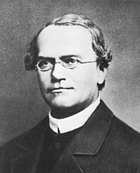
CCR5 is a receptor for immunoregulatory substances present on the surface of white blood cells. As is typical for many genes involved in immune system function, it is involved in precise tuning of the immune response under specific conditions (e.g., fighting particular pathogens), though its function is not vital for the function of the immune system as a whole. Therefore, mutation in a CCR5 encoding gene is not linked to marked differences in phenotype. In case of the CCR5-Δ32 mutation (A deletion mutation of 32 nucleotides. Δ denotes the Greek letter delta.), a mild statistical phenotype is observed, manifesting as more severe symptoms during influenza and zika infections. In short, the lack of functional CCR5 attenuates the immune response. This may be beneficial in a situation when a too strong immune response is causing damage (immunopathology). Some medieval plagues are presumed to have shaped the recent population genetic polymorphism in European populations so that the number of individuals carrying the CCR5-Δ32 mutation was enriched. These individuals are descendants of plague survivors.
On the other hand, CCR5 is also a key co-receptor for HIV. When it is absent from the cell surface, the risk of viral infection is almost completely abolished. This strong antiviral phenotype is more frequent in Europeans. Even in CCR5 heterozygotes, the HIV infection is attenuated and takes significantly longer to manifest immunosuppressive symptoms.
During the academic year we collected buccal smear samples (containing detached cells from stratified mouth epithelium) from almost all Erasmus students at Charles University (to characterise the genetic variability of the Europeans similar to the EOES competitors) as a material for genetic analysis. The overall results are:
- Dominant homozygotes: 155
- Heterozygotes: 25
- Recessive homozygotes: 1
Task A1 (3 points)
Question A1.1 What is the overall frequency of wild-type CCR5 (e.g., “normal”) and mutant CCR5-Δ32 alleles in “Erasmus human population” (which can be assumed to be in Hardy-Weinberg equilibrium)? The Hardy-Weinberg equation used to determine genotype frequencies is:
p² + 2pq + q² = 1. (1 points)
Question A1.2 Last two years were highly affected by the COVID-19 pandemic which was studied in detail, including studies taking its interaction with CCR5-Δ32 into account. Interpret the graphs below from the publication with heading on the right.
On the x-axis is the frequency of the CCR5-Δ32 allele, and on the y-axis is the quantification of A) COVID-19 cases/million and B) COVID-19 deaths/million.
B
A
Fig. A1 Correlation between CCR5-Δ32 allele frequency and COVID-19 prevalence and mortality in Europe. (A) The number of COVID-19 cases per million inhabitants (r=-0,347, p=0,035). (B) The number of COVID-19-related deaths per million inhabitants (r=-0,444, p=0,006).
Number of COVID-19 deaths / million
Number of COVID-19 cases / million
Which of the following statements A–D can be used as a correct interpretation of the plotted data? (1 point)
- There is no statistical correlation between the outcome and severity of SARS-CoV-2 infection and CCR5-Δ32 mutation frequency.
- A stronger protective effect of the CCR5-Δ32 mutation can be seen in the number of deaths compared to the sum of infections.
- The immune system actively contributes to the pathology of COVID-19.

Question A1.3 The most abundant monogenic disease in Europe is cystic fibrosis with approximately 1/30 frequency of the deleterious recesive allele (the particular frequency and identity of the mutation depend on geographic location and local genetic background). What is the corresponding average frequency of people who suffer from cystic fibrosis in Europe? Assume that the population is in Hardy-Weinberg equilibrium. The Hardy-Weinberg equation used to determine genotype frequencies is:
p² + 2pq + q² = 1. (1 point)
Task A2 (9.5 points + 5 points for loading and optimal running of electrophoresis –14.5 points total)
Our CCR5 genetic analysis was performed using a PCR reaction with specific primers flanking the mutated region. Different lengths of the PCR products correspond to the wild-type and mutant allele. You obtained three Eppendorf vials with typical results for recessive and dominant homozygote + heterozygote together with molecular weight size marker (DNA ladder).
Question A2.1 Load individual DNA samples (vials 1–3) and molecular weight size marker (DNA ladder) (all 20 μL) into appropriate wells in the precast agarose gel and run the gel. Arrange the loading pattern of samples and molecular weight standards according to rational experimental practice. Draw your loading design in the box in the Answer sheet first. (1 point)
Question A2.2 The figure below shows the typical result of CCR5 genotyping performed according to the same methodology as we use here. (1.5 points)

Write which of the samples 1–3 correspond to
Dominant homozygote, heterozygote and recessive homozygote in the Answer sheet.

Question A2.3 The PCR used to prepare the samples was run for 20 amplification cycles. What is the resulting number of amplified molecules if the PCR started from DNA isolated from a single human somatic cell and the reaction conditions were ideal? For the definition of the amplified region, a single pair of primers was designed and used. Write the numbers of amplified molecules for Dominant homozygote, Heterozygote (specify the number of dominant/recessive copies), and Recessive homozygote in the Answer sheet. (2 points)

Question A2.4 The number of nucleotides missing in the CCR5-Δ32 mutation is 32. Which of the following statements A–D) is/are true for the severity of the mutational outcome? Mark your answer in the Answer sheet. (1 point)
- The result is shortening of the CCR5 by 8 amino acids and no shift in a reading frame, since human leucocytes use a 4-letter genetic code.
- The result is a shortening of the CCR5 and a shift in a reading frame that typically leads to a premature termination of translation resulting in the substantial shortening of the protein product.
- Shortening of the CCR5 gene leads to a shift in a reading frame that typically leads to inhibition of translation termination, which results in the production of a longer protein.
- Similar severity of the phenotype could be observed in CCR5-Δ1 or CCR5-Δ2 mutation, but not in CCR5-Δ3.
Question A2.5 One of the recent major bioethical controversies is linked to CCR5. The first use of genome editing in viable human embryos was performed by a Chinese scientist He Jiankui in 2018. He altered the genomes of two human embryos – twin sisters known under the pseudonyms Lulu and Nana. The intention was to create HIV-resistant human beings by introducing the CCR5-Δ32 mutation in the genome. Two days after Lulu and Nana were born, whole genome sequencing of DNA from their blood samples confirmed the mutations. However, the available sources indicate that Lulu and Nana carry incomplete CCR5 mutations. Lulu carries a mutated CCR5 gene that has a 15-bp deletion on one chromosome 3 while the other chromosome 3 is normal (heterozygous allele). Nana carries a homozygous mutant gene with a 4-bp deletion and a single base insertion in close proximity.
Which of the two sisters could most likely to be fully resistant to HIV? Indicate your answer in the Answer sheet. (1 points)
Question A2.6 Distinguish the structure formulas of DNA and RNA from each other (indicate this by writing ‘DNA’ or ‘RNA’ in the boxes provided in the Answer sheet. Circle the difference in chemical structure between DNA and RNA in the sugar part in both drawings using a blue pencil. (3 points)
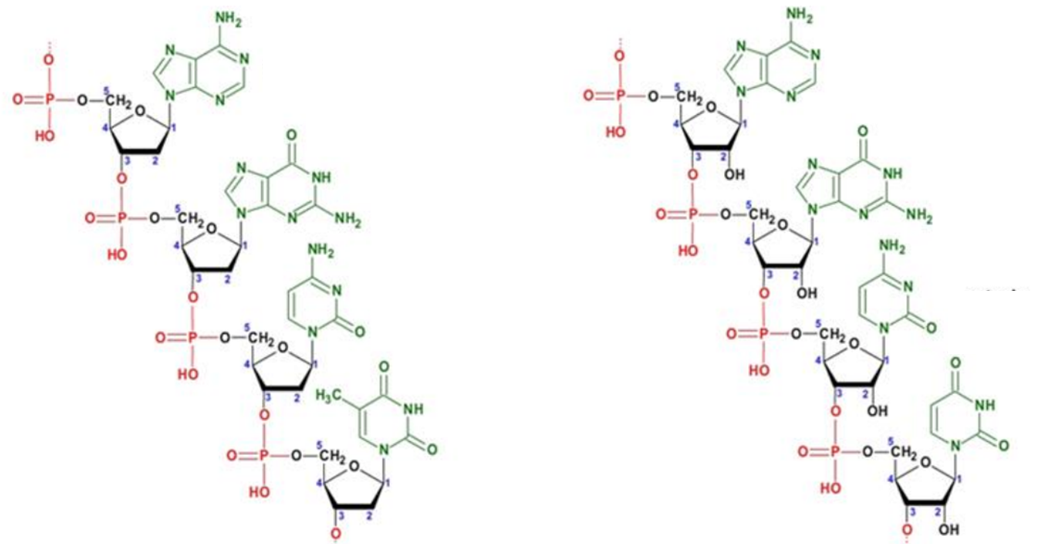
JAN JANSKÝ
G. J. Mendel’s postulates were based on using an allelic pair of one dominant and one recessive allele. However, in reality, co-dominance of various alleles may also occur and contribute to phenotypic plasticity. A well-known example combining the concepts of dominance and co-dominance is genetics of the AB0 human blood group system. The underlying mechanism of blood group (in)compatibility, a phenomenon essential for safe blood transfusion, is based on the expression of variable glycosyltransferases that modify the amphipathic membrane components – glycolipids with different sugar moieties. An important contribution to the blood group classification was made by Jan Janský, a Czech serologist, neurologist, and psychiatrist who is credited for the classification of blood into four types (I, II, III, IV) including the AB blood group that remained unrecognised till Janský discovered it in 1907.

Task A3 (6 points)
The figure bellow provides a result of an AB0 blood group testing of an unknown sample with anti-A and anti-B antibodies. Use of the particular antibodies is indicated.

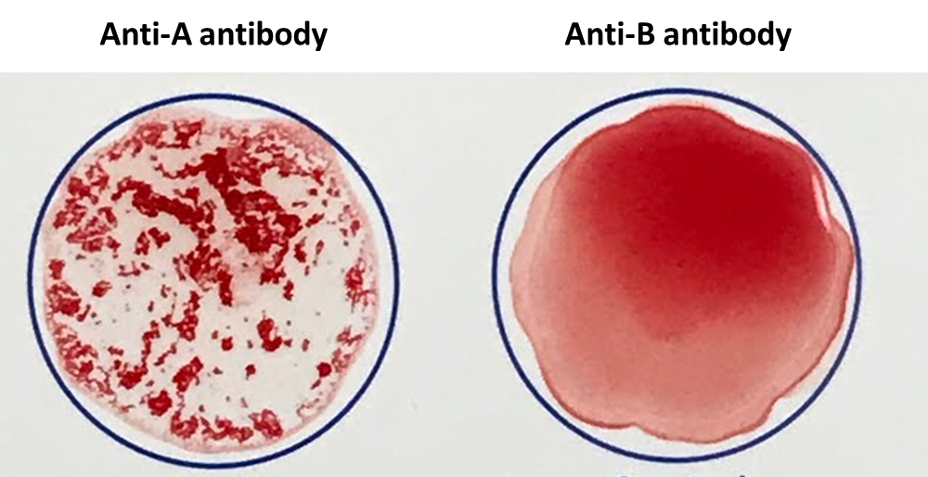

Question A3.1 To which blood group/groups does the depicted sample belong? (1 point)
A
B
AB
0
Question A3.2 Blood groups, which can be identified by using antibodies, are the phenotypes. What would be genotype/genotypes for all 4 blood groups? Use A, B, and 0 to denote alleles. If more than one genotype exists, include all possible genotypes. Omit rare alleles of other genes interacting with the AB0 system, such as the h allele responsible for the Bombay phenotype. (1 point)
A:
B:
AB:
0:
Question A3.3 (1 point)
Which allele/s is/are codominant?
Which allele/s is/are recessive?
Question A3.4 Draw a schematic explanatory figure depicting the role of antibodies in blood group identification for the sample from question 3.1. Red blood cells and antibodies don’t need to be in scale. (1 point)

Question A3.5 Antibodies (immunoglobulins) are proteins produced by B-lymphocytes (B-cells) during immune response and optimised for high-affinity binding to particular antigens. Which of the pictures A–D corresponds to the 3D conformation of an antibody? Indicate the correct letter in the Answer sheet. (1 point)
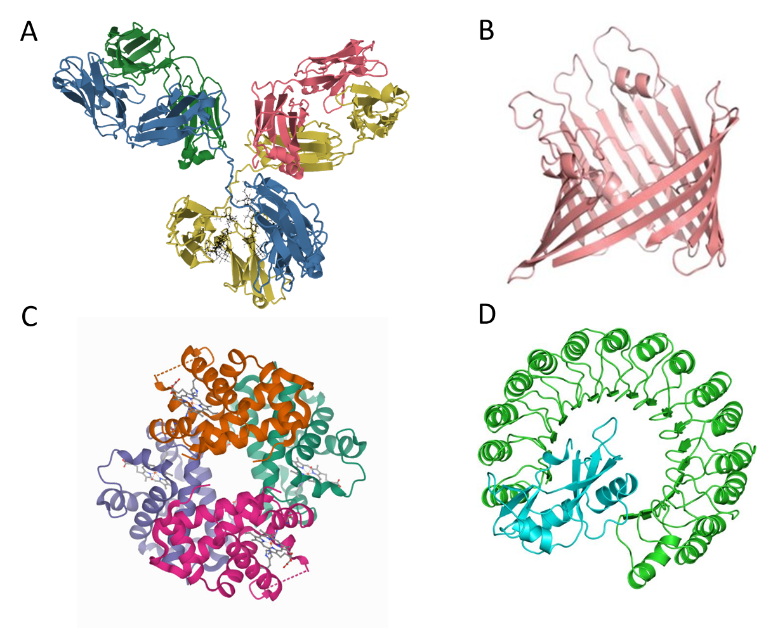

Question A3.6 Imagine that a plasmatic cell (B-cell producing soluble antibodies specific for a particular antigen in large quantities) is used for animal cloning. What will be the immunological phenotype of the experimental animal? (1 point)

- There will be no difference between cloned and naturally born animal.
- The animal will produce only one type of T-cells.
- The animal will be able to produce only one type of antibody specific to one antigen.
- Immunodeficiency.

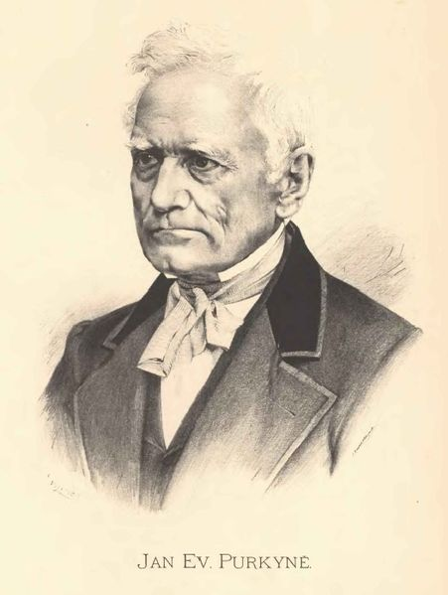
JAN EVANGELISTA PURKYNĚ
Cell theory (Omnis cellula e cellula) is one of the major intellectual concepts in life sciences. In the middle of the 19th century, the definition of the cell as the smallest unit of life was independently formulated by J. E. Purkyně, a Czech physiologist, T. Schwann, a German physiologist, and M. J. Schleiden, a German botanist. Since then, cells have garnered the attention of many scientists. As a result, cell biology nowadays belongs to the fundamentals of not only biology, but also medicine. The hallmarks of life and cell structure and physiology are generally the same. Continuation of the complex life forms involves molecular and cellular turnover, energy consumption and dissipation, or the use of DNA or RNA as information storage media. However, defining life is not an easy task, not even today…

Task A4 (13 points + 6 points for blood smear specimens – 19 points total)
You are provided with 3 microscopic slides (numbered 1–3) with fixed red blood smears
(from mammal, bird, and amphibian). Prepare stained blood smear specimens using Giemsa stain (binding to negatively charged cellular components, incubate for 20 minutes in the provided Giemsa solution, use Pasteur pipettes to cover the smear with the staining solution.) and finally wash with distilled water in a wash bottle. Let the specimens dry up before observation. Wear gloves during the staining procedure.
Observe the specimens using immersion oil and immersion objective:
- Rotate objective lens ring to a position between 40x and 100x objectives (neither lens will be locked in place.)
- Remove slide from stage. Add a drop of immersion oil. Return slide (with oil) to stage or, leave the slide on the stage and add the oil drop directly.
- Rotate the 100x objective lens into place.
- Use coarse focus knob to raise the stage until the 100x lens just touches the oil.
- While looking into the microscope, use fine focus knob (turn clockwise, to raise the stage) to find the plane of focus where the specimen is.
Question A4.1 Draw representative images of all blood smear specimens prepared by yourself (use immersion oil and corresponding 100x magnification objective). (3 points)
Question A4.2 Identify the blood source of each sample and write the corresponding number of the slide in the proper box in the Answer sheet (1 point)
Mammal blood:
Bird blood:
Amphibian blood:
Question A4.3 Draw a picture of the mammal to which the mammalian blood smear belongs. The best drawing will be awarded a special price! (0 point!!! but you can win special prize)
Question A4.4 You are provided with statements A–D. Write the corresponding letters of all statements that apply to the slides into the boxes provided in the Answer sheet. You may use the same statement more than once. (1 point)
- Erythrocytes contain haemoglobin as an oxygen carrier.
- Erythrocytes constitutively produce proteins.
- Erythrocytes could undergo oncologic transformation.
- Erythrocytes develop from the precursor cell by mitosis.

Question A4.5 The size of the cell is influenced by the size of the genome, and the size of the cell’s nucleus also correlates with genome size. Test the hypothesis that the nucleo-cytosolic ratio is constant in the majority of cases, including red blood cells. The figure provided below shows sizes of cells and the sizes of the haploid genome from samples 2 and 3. Calculate the nucleo-cytosolic (genome-cytosolic) ratios for both cell types (consider the shape of the cells to be an ideal ellipsoid where b=c), state the units in the Answer sheet. Don’t forget that the erythrocytes come from diploid organisms! (3 points)
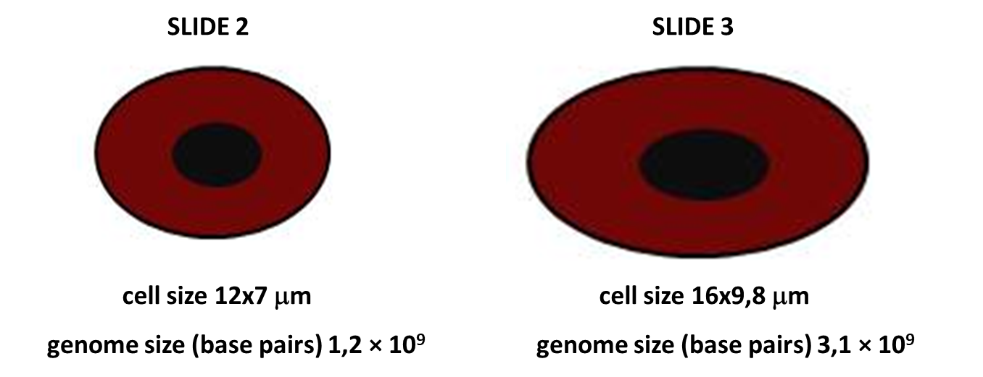
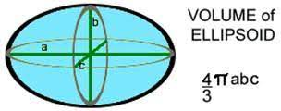

sample 2
sample 3

Based on your results, decide whether the hypothesis that the nucleo-cytosolic ratio is constant (close to an average value with difference less than 5%) is true for the red blood cells.
TRUE/FALSE
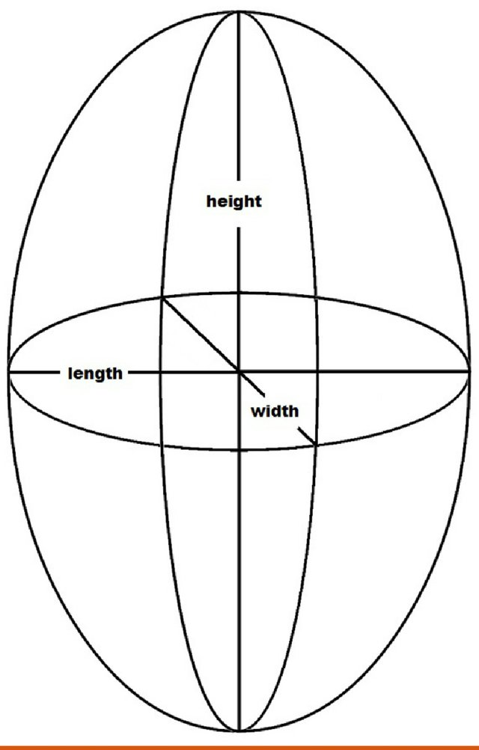
Question A4.6 The size of the nucleus corresponds to the size of the genome. The Australian lungfish (Neoceratodus forsteri) genome is the largest animal genome ever sequenced. With 43*10⁹ base pairs (in haploid state), it is 14 times larger than the human genome, and it exceeds the genome of the Mexican axolotl (Ambystoma mexicanum), the previous largest genome record holder in the animal kingdom, by an impressive 30%.

What would be the volume of the lungfish red blood cells? What would be the height and length (length= width, b=c, height is 1,5x longer than length) of the lungfish red blood cells? Use the mean value of the nucleo-cytosolic ratio from your results for samples 2 and 3. (1 point)

Question A4.7 The human red blood cell (RBC) exhibits remarkable deformability and durability. During its four-month lifespan, a human RBC circulates the body about a million times and undertakes a journey of about 500 kilometres. The deformability and durability of RBCs is determined by plasma membrane viscoelasticity, cytoplasm viscosity, and geometry of the cell. The resting RBC adopts a unique shape with a surface area to volume (SA:V) ratio ~1.5-fold greater than a sphere of the same volume. How is that achieved? Draw a side cross section (through the middle of the cell) view of the RBC. (1 point)
Question A4.8 What would be the surface volume ratio for the cells in the sample 2 and 3 and those of lungfish origin? (1,5 points)
(SA:V) ratio (slide 2)
(SA:V) ratio (slide 3)
(SA:V) ratio (lungfish)
The formula for the calculation of ellipsoid surface area is: 4π[((ab)^{1.6}+(ac)^{1.6}+(bc)^{1.6})/3]^{(1/1.6)}.
Question A4.9 All living things have certain traits in common: cellular organisation, the ability to reproduce, growth and development, energy use, homeostasis, response to their environment, and the ability to evolve. Taking into account these hallmarks of life/cellularity – erythrocytes from which sample/samples are not alive? Mark the appropriate sample/s with a tick (✓) in the proper box in the Answer sheet. (1,5 points)
Slide 1:
Slide 2:
Slide 3:

Task A5 (7.5 points)
You are provided with another two blood smear specimens stained with Giemsa stain (labelled A and B), containing a healthy person’s blood and the blood of a patient afflicted with an unknown pathology.
Question A5.1 Draw representative images of both samples under 100x magnification using immersion oil. (2 points)
Question A5.2 Write in the Answer sheet which of the two samples (A or B) is pathological. Write your answer in the box. (0.5 point)
Question A5.3 Which of the following pathologies correspond to the phenotype observed under the microscope? (1 point)
- Sickle cell anaemia
- Polycythaemia vera (higher than normal erythrocyte count)
- Anaemia caused by lack of iron
- Leukaemia
- Malaria
- Thalassemia
After answering, raise your hand. A lab assistant will stamp your answer and provide you with the rest of the tasks for Part A5.

Part B
List of equipment for Part B:
- Red laser (wavelength of the laser $λ = 640 nm$)
- Clamps
- Optical rail
- Holder with hair
- Holder with helical spring
- Measuring tape
- Caliper
- Screen
- Pencil
- Calculator
Double helix structure of the DNA
The molecule of deoxyribonucleic acid (DNA) has a double helix structure, which was described in 1953 by James Watson and Francis Crick. This description is based on the X-ray diffraction image taken by Rosalind Franklin and her student Raymond Gosling. In this assignment, you will study diffraction theoretically and practically.
Diffraction is a phenomenon that occurs when a wave encounters an obstacle or opening. It can be a wave on the water surface, a wave of light, or the X-ray wave mentioned above. Diffraction is most clearly observable when the physical dimensions of the obstacle are comparable to the wavelength of the incident wave due to so-called interference.
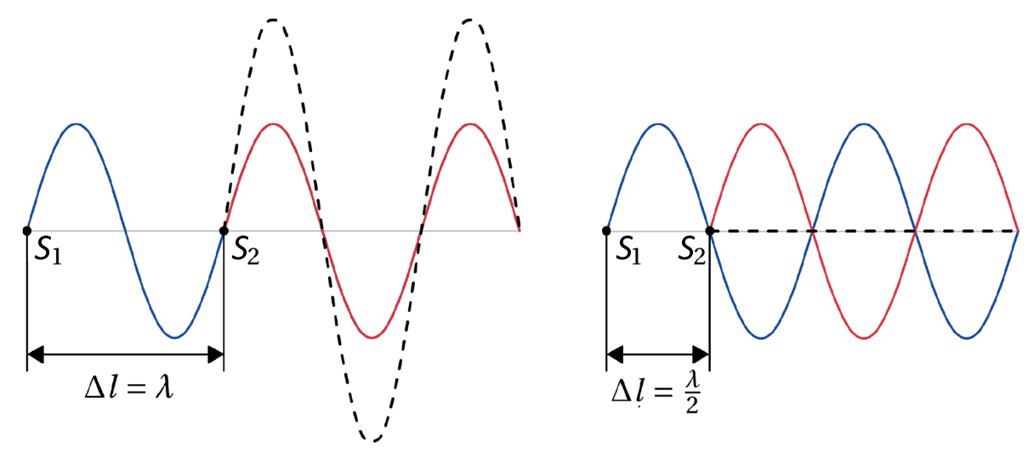
Fig. B1 Constructive and destructive interference.
To understand interference, let us consider two waves with the same wavelength $λ$ propagating from the two sources S₁ and S₂ (Fig. B1). If these two sources are separated by the distance $∆l$ (sometimes denoted path difference), the amplitudes of these two waves will add up at each point. If the path difference is the same as the wavelength $λ,$ the maximum of the wave from the source S₁ will add to the maximum of the wave from the source S₂, resulting in greater amplitude. This will also happen if the path difference will be $kλ,$ where $k=0, 1, 2,…$ The constant $k$ is usually called the order of maximum, and we can write
$${∆l}_{max}=kλ=2k\frac{λ}{2}$$ | (1)

and this phenomenon is called constructive interference. In terms of light, this corresponds to a bright spot on the screen.
If the two sources are separated by the path difference $∆l$ equalling $\frac{λ}{2},$ maximum of the wave from the source S₁ will add to the minimum of the wave from the source S₂, and so on. This will result in cancelling the waves out (if these waves have the same amplitude). This also applies to all situations where the path difference is a half-number multiple of the wavelength:
$${∆l}_{min}=(2k-1)\frac{λ}{2},$$ | (2)

where $k=1, 2,…$and is the order of the minimum. This whole phenomenon is called destructive interference, and in terms of light, it corresponds to the dark spot on the screen.
The light used in these experiments must have special properties so that you will use the light of the red laser.
IMPORTANT: Do not shine a laser light on your eyes! Beware of even random reflections from shiny objects! The design of the experimental apparatus almost eliminates this, but please be careful anyway.

Task B1 Diffraction of light on the hair (10 points total)
In this task, you will familiarize yourself with the basic properties of light diffraction. When light strikes an obstacle, as shown in Fig. B2, the observed diffraction pattern is similar to the one observed after passing light through a single narrow slit. Just as in the one-dimensional case of Fig. B1, $Δl$ between these two light rays can be calculated, in this case as
$$∆l = d sin θ,$$ | (3)
where $d$ is the width of the obstacle. Note however, that the conditions for constructive and destructive interference from the introductory text are opposite for the case of a single slit.
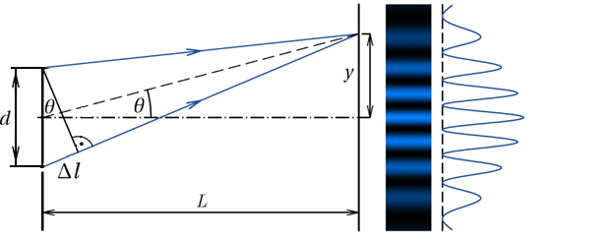
Light
intensity
Fig. B2 Diffraction of light on an obstacle.
Question B1.1. Write to the Answer Sheet the conditions for the diffraction minima and maxima during diffraction of light on the hair using equations (1) and (2). (3 points)
As you can see from Fig. B2, the angle $θ$ can be calculated from the geometry of the experimental apparatus due to the similarity of the triangles.
Turn on the laser with the button closer to the screen and observe the diffraction pattern. It should be similar to that one from Fig. 2: alternating light and dark stripes. The central bright spot is the zeroth maximum (for $k=0$), then first minimum, first maximum, second minimum, and so on alternates. By measuring their distance from the zeroth maximum $y$ you will find the corresponding angles $θ_{k}$ and calculate the hair diameter $d$.
For the pattern to be large enough to measure the distances of the individual minima, it is necessary to place the screen at a distance of at least one meter. You will measure the distance from the hair sample to the screen and mark it as $l$. You can mark important points for measurement on the screen with a pencil and measure distances afterward, or measure straight from the screen using a caliper.
We denote the distance measured from the center of the zeroth maximum to the center of the first left minimum as $y_{11}$. The distance measured from the center of the zeroth maximum to the center of the first right minimum is denoted as $y_{12}$. Using the arithmetic mean of these two values, we find the distance $y_{1}$, which we will need for further calculations. Continue in a similar way to measure minima of the following two higher orders (also on the other side of the interference pattern). Record the measured values in the table in the Answer Sheet.
Question B1.2 Fill in the table in the Asnwer Sheet and calculate the final value of $d$ as the arithmetic mean of the all three $d_{k}$ values. (7 points)

Task B2 Diffraction of light on the helix (22 points)
IMPORTANT: Slide the screen off the rail, then slide off the holder with the hair. Then slide in the holder spring and slide back the screen. If you power up the laser, the diffraction pattern should look like in Fig. B3b.
If there is not one circular obstacle but a helical spring, the situation is slightly different. Helical spring with wire diameter $d$, spacing $S$, thread radius $R$, and perpendicular distance of wires $P$, which form an angle $β$with each other (see Fig. B3a) will produce an diffraction pattern that is depicted in Fig. B3b.
Fig. B3a Geometry of the helical spring. | Fig. B3b Diffraction pattern.

The “X”-pattern of the diffraction maxima is an indication of a helical structure. The inclined segments which make the front view of a helix give rise to an inclined lines of diffraction peaks. The angle between the segments is equal to $β$.
You can observe two different structures: a coarser (see the yellow arrow in Fig. B3b) and a finer structure (see the light blue arrow and bar in Fig. 3b). The coarse structure corresponds to the smaller characteristic size of the helical spring $d$, whereas the fine structure corresponds to the larger length $P$. It can be shown that the distance $x$ between two neighbouring minima of the coarse structure on the screen is connected to the wire diameter $d$ by this equation:
$$d=\frac{λL}{x}.$$

Measure the distance $x$ ten times on the screen (between neighbouring minima), write it into the Answer Sheet, and use this data (along with the screen distance $L$) to calculate the values of $d$ and $β$. Calculate the absolute errors of these quantities. We determine the observation error as the arithmetic mean of the deviations of individual measurements.
As the first step, you will write down the calculated values in the tables. Then you determine the absolute deviations of individual measurements $Δd$ by calculating the absolute value of the difference between the calculated arithmetic mean $\overline{d}$ and the individual measurements:

$$∆d=\left| \overline{d}- d\right|$$
So for the first measurement, we calculate the absolute value of the arithmetic mean minus first measured value, for the second measurement we calculate the absolute value of the arithmetic mean minus second measured value and so on.
The final value of the absolute error $∆\overline{d}$ is the arithmetic mean of the individual absolute errors from the last column of the tables. Round this deviation to one significant digit and round the arithmetic mean to the same number of decimal places as the absolute error.
Question B2.1 Fill in the tables in the Answer Sheet and Write down the measured value in the form of $d=(\overline{d}±∆\overline{d})$. Calculate the same for $β$. Write the value of $L$ to the Answer Sheet. (16 points)
For the fine structure a relationship similar as for the coarse structure can be used. The distance of wires $P$ can be calculated by the distance $b$ between neighbouring minima of the fine structure and the following equation:
$$P=\frac{λL}{b}$$
Now you will estimate the quantity $P$. For this purpose count the number of minima of the fine structure that are present between two neighbouring minima of the coarse structure.
Hint: If you are not able to see the fine structure you can measure the distance between the two minima of the coarse structure and count the minima of the fine structure in Fig. B3b with no punishment.
Question B2.2 Write down the number of the minima of the fine structure that are present between two neighbouring minima of the coarse structure in the Answer sheet. Also write down the distance between the used minima of the coarse structure. Calculate the distance $b$ between the minima of the fine structure and the perpendicular distance of wires $P$ and write your answer in the Answer sheet. Write also the value of $L$ to the Answer Sheet. (6 points)
Task B3 Diffraction of X-rays on the DNA helix (18 points)
Rosalind Franklin and her student Raymond Gosling took an X-ray diffraction image of a gel composed of DNA fiber in May 1952. This now-famous Photo 51 is in Fig. B5. Assume that the image is ten times larger than the original, which was captured using X-rays with a wavelength of $λ = 0,15 nm.$ The screen was in the distance of 13.0 mm from the DNA sample.
Question B3.1 Measure ten times the separation $b$ between different neighbouring maxima using a caliper. Using only the caliper (and trigonometric formulas), determine the angle between diffraction patterns and calculate $β$. Draw everything you need in the image in the Answer Sheet to substantiate and explain your reasoning. Using formulas from Task B2, calculate the parameters $P$ and $β$ of the DNA helix. (16 points)
DNA, in fact, is a double-helix structure, which can be proven with missing fourth maxima).
Question B3.2 Why the X-rays have to be used to examine the structure of the DNA instead of light? State your answer using mostly mathematical symbols and physical quantities. (2 points)
Fig. B5 Photo 51.

Part C
Antivirals
List of laboratory equipment:
- glass pipettes
- 20 TLC plates (silica gel, specifications)
- ‘IPAV’ solvent
- TLC cells or small beakers covered with Petri glass (at least 4 per team)
  - permanganate solution for TLC visualisation
- 10 unknown samples (marked A-J)
- Sodium periodate solution
- 12 Eppendorf vessels for reacting the samples with reagent solutions
- 10ml and 20ml graduated cylinder
- UV lamp (for more teams)
- Ammonia water (for more teams)
- 2-propanol (for more teams)
- distilled water (for more teams)
- Acidic solution (concentrated hydrochloric acid, for more teams)
- tweezers for TLC plates
- automated pipettes
- pencil, marker
- calculator
- plastic pipettes
- tape

Antonín Holý (1936-2012)
Nucleotide analogues (NAS) were synthesised by the team of Antonín Holý in the Institute of Organic Chemistry and Biochemistry (Prague, Czech Republic). NAS are used worldwide to treat various viral infections. Some of these derivatives such as Adefovir, sold as Vireon or Hepsera, are used to treat chronic hepatitis B infections. Tenofovir, in the form of tenofovir disoproxil or alafenamide, is used in combination with other antivirals to suppress HIV effectively. DHPA was the active ingredient of Duviragel, a treatment for the herpes simplex virus.
In this task you are provided with 10 unmarked samples labelled A-J, which contain different nucleotide analogues and natural products. You will try to identify the compounds by considering their chemical properties, followed by chromatographic investigation.
Task C1 (11 points)
Drawings of structures of organic compounds are often simplified to make them more compact or to leave out the elements that are not as essential in certain cases.
Below you will find a small guide on some of the structures included in the task.
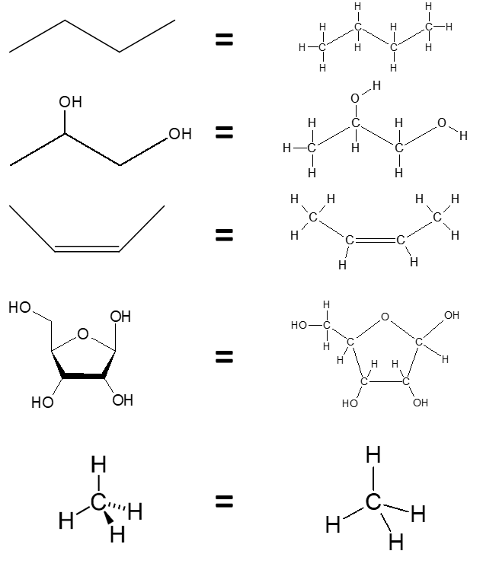

Element is pointed into the planar plane (away from the viewer)
Element is pointed out of the planar plane (towards the viewer)

N.B. A wiggly or wavy (~) bond should be interpreted as either a dashed bond pointing away from the viewer or a wedged bond pointing towards the viewer.
Below a set of molecule structures corresponding to samples A-J is provided. Some of them are natural products, and some are antivirotics prepared by the team of Prof. Holý. The molecular structure of these compounds (Figure C1.1) can be used to predict specific properties, such as molecular mass, optical rotation, reactivity, and UV absorbance.
Figure C1.1 - The molecular structures of compounds 1-10
Systematic and trivial (in brackets) names for the compounds:
I — (2R,3R,4S,5R)-5-(hydroxymethyl)oxolane-2,3,4-triol (ribose)
II — 9H-purin-6-amine or 6-aminopurine (adenine)
III — {[2-(6-amino-9H-purin-9-yl)ethoxy]methyl} triphenylmethyl ether
IV — (2S)-3-(6-amino-9H-purin-9-yl)-1,2-propandiol
V — {[2-(6-amino-9H-purin-9-yl)ethoxy]methyl}phosphonic acid (Adefovir)
VI — (2R,3R,4S,5R)-2-(6-amino-9H-purin-9-yl)-5-(hydroxymethyl)oxolane-3,4-diol (adenosine)
VII — ({[(2R)-1-(6-amino-9H-purin-9-yl)-2-propanyl]oxy}methyl)phosphonate (Tenofovir)
VIII — 2-deoxy-D-ribose (deoxyribose)
IX — triphenylphosphine oxide
X — 4-methylbenzenesulfonic acid (PTSA, Paratoluen sulphonic acid)

Question C1.1 Match each compound (1-10) to its name (I-X, either trivial or systematic). (4 points)
Optically active substances can change the orientation of plane polarised light. To decide whether a compound should be optically active, one needs to look for optically active centres. In organic substances these are mainly carbon atoms. Such atoms are called chiral.
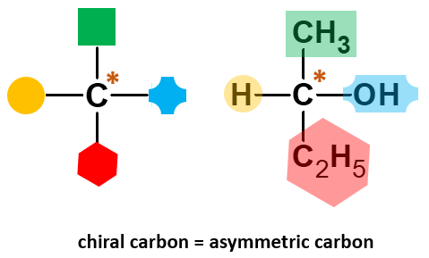
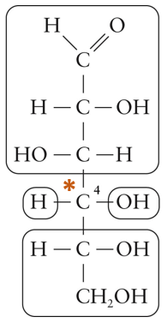
Chiral carbon C atom is a C atom with 4 different groups connected to it (as carbon forms 4 possible covalent bonds). Below you will find an example of a chiral carbon atom in a carbohydrate molecule

Fig. Cx. Example of a chiral C atom in glucose molecule.
Question C1.2 State which of the given structures (1-10) have optical activity (e.g. they can change the orientation of plane polarised light, circle the chiral carbon atom, at least one in the answer sheet). (5 points)

Question C1.3 Compounds with conjugated double bonds can absorb light in the UV area. On the Answer sheet, indicate which of the compounds can be detected by UV light. (2 points)

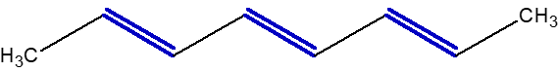
Fig. Cx. Example of a structure with conjugated (=multiple alternating) double bonds

Task C2 (39 points)
Thin Layer Chromatography
Structural analysis is an essential part of organic chemistry. Any analytical method can be described by the information it can provide, its accuracy, length of analysis, and very importantly its cost (of the analytical instrument, solvents, etc.).
In this task, you will get acquainted with thin-layer chromatography (TLC). This technique is used to separate non-volatile mixtures. The analysis is performed on a sheet of an inert substrate (such as aluminium foil) which is coated with a thin layer of adsorbent material, usually silica gel.
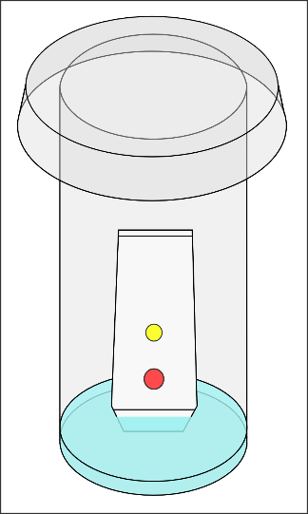
A glass pipette is used to transfer a minute amount of the analysed mixture and mark a spot on the “Start” line on the TLC plate (Fig. 6). The spots should preferably be as small as possible. A developing chamber (a beaker with a Petri dish on top of it) is filled with a desired eluent (or ‘mobile phase’) so that the level of the solution is 2-3 mm high from the bottom. The spotted TLC plate is then placed vertically into the TLC chamber using tweezers and the chamber is covered with the Petri dish (Fig. 7). When a sample has been applied to the plate, the mobile phase is drawn up the plate via capillary action. Because different analytes ascend the TLC plate at different rates, separation is achieved. With silica gel, compounds with lipophilic groups (alkyl, aryl) move faster (further) on TLC. On the contrary, ions and molecules with polar functional groups (OH, =O, SH, -O⁻) move slower on TLC. The interaction grows stronger with an increasing number of polar groups.
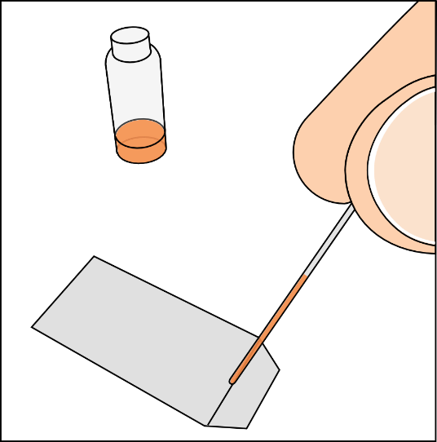
Figure X. Spotting of a TLC plate Figure Y. Development of a TLC plate
During the experiment the eluent will travel up the plate. When the eluent reaches the “Finish” line the plate must be removed from the chamber. The retardation factor (R_{f}) for every spot on the TLC plate can then be calculated.
R_{f} is the ratio of the distance travelled by the centre of the spot to the distance travelled by the solvent front. For example, if a particular substance travels 2.5 cm and the solvent front travels 5.0 cm, the R_{f} would be 0.50. Every chemical compound has a unique R_{f} value which is dependent on the eluent.
After the experiment, the spots have to be visualised. One way is to simply by projecting ultraviolet light onto the sheet. The TLC plates are doped with a fluorescent indicator. If a compound with conjugated double bonds is present, it absorbs the UV light and the spot looks dark under the UV lamp.
Contrast reagents can also be used to visualise the spots - dipping the TLC plate in permanganate solution causes oxidation of the sample. Reduced permanganate can then be observed as yellow spots on a brown background.
The set of 10 unknown samples labelled A-J that you have been provided with, correspond to the compounds 1-10 in Figure C1.1. Your objective is to find out which sample corresponds to which compound. In this task, you will employ TLC and some specific chemical reactions to help you answer this question.
As the mobile phase, you will use a mixture of isopropanol (propan-2-ol or 2-propanol) and dilute ammonia, known as ‘IPAV’.
Question C2.1 Spot compounds A-J on a TLC plate in a 2x5 grid (you are not going to use this plate for chromatography, so you can use the full plate). Make sure to label each spot (by pencil!!) with its corresponding letter. Allow the spots to dry completely, since wet spots will give false positives under UV-light and with the permanganate stain. Place the plate under the UV lamp and observe which compounds absorb UV light. Write down the letters of the compounds absorbing UV light on the answer sheet.
Then, use the tweezers to briefly submerge (‘dip’) the TLC plate in the potassium permanganate solution. If you cannot completely submerge it at once, take it out, and dip it in the solution upside down. Let any remaining liquid drip from the plate. Lay it down on a paper towel or tissue and let it rest for 5 minutes. Some of the spots will turn a clear yellow; the compounds in these spots have been oxidised by the permanganate. (Some other spots may turn slightly yellow over time as well, but you can disregard those.) Write down the letters of the compounds that clearly turn yellow on the answer sheet. (5 points)
Paste the plate on the last page (labelled ´TLC plates´) of the answer sheets.
Question C2.2 Perform TLC experiments with samples A-J. Use a suitable detection method (UV lamp or permanganate solution). Calculate the Rf values (see the picture below) and write them down into the Answer sheet. Use a pencil to mark the spots on the TLC plates and paste them on the last page (labelled ´TLC plates´) of the answer sheets and write down the sample letters (A-J). You can add up to 3 spots on one TLC plate. (10 points)

Question C2.3 For running a reliable and reproducible TLC you need to know the exact composition of the solvent. Unfortunately the composition of IPAV is not available. Try to make an approximation to that exact composition by preparing 5 solutions:
90% 2-propanol plus 10% ammonia
80% 2-propanol plus 20% ammonia
70% 2-propanol plus 30% ammonia
50% 2-propanol plus 50% ammonia
30% 2-propanol plus70% ammonia.
Choose 2 suitable compound (A - J) (not too fast and not too slow) and run individual TLCs with your prepared mixtures. Write Rf values for the different mixtures into the table. Use a pencil to mark the spots on the TLC plates and paste them on the last page (labelled ´TLC plates´) of the answer sheets and write down the letters (A-J) of the samples that zou used.
Indicate which mixture corresponds to IPAV in the answer sheet. (6 points)
Reaction with periodate ion can be used to detect the presence of vicinal diols (hydroxy groups on two adjacent carbon atoms). The general reaction is as follows:
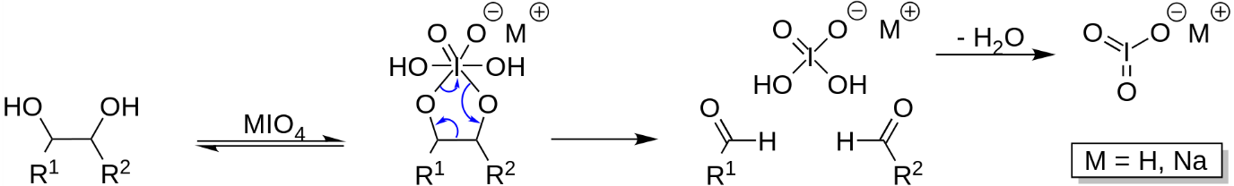
And this is an example of the oxidation of compound 1:
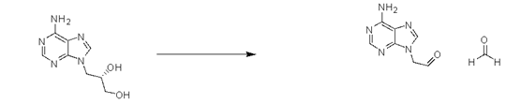

Question C2.4 Some samples can react with periodate anion by the mechanism explained before. Using a pipette, mix 10 drops of sample with 3 drops of periodate solution in an Eppendorf tube and let it stand for 10 minutes. Then use TLC again for analysis, similar to what you did earlier. Use a pencil to mark the spots on the TLC plates and paste them on the last page (labelled ´TLC plates´) of the answer sheets and write down the sample letters (A-J). Based on your observation, which samples reacted with sodium periodate solution? (8 points)

Question C2.5 One of the samples A-J is a precursor of DHPA. Acidic treatment of this sample provides the antiviral compound. The precursor can be revealed in the vapours of hydrochloric acid. Alternatively, you can mix a few drops of the sample with concentrated HCl and perform TLC. Which sample is the precursor? And which sample is DHPA? (10 points)
Trityl moiety in organic compounds can be cleaved with the help of strong acid:
• All 10 samples (A - J) should be spotted on a single TLC plate at a reasonable distance from each other and described with letters Mark the spots on the TLC plate with the corresponding letters (A - J).
• The TLC is given to the lab assistant to put it in the chamber with hydrochloric acid vapors.
• Spot of tritylated DPHA will change the color to yellow the rest will stay unchanged. Mark the coloured spot and paste the plate on the last page (labelled ´TLC plates´) of the answer sheet.
• Lab assistant will add few drops of concentrated hydrochloric acid to your sample with tritylated DPHA. Wait for 1 minute and apply a dot of resulting mixture on TLC plate.
• Develop the plate in IPAV mobile phase. Compare the retention facter with the retention factor of compounds in experiments before. The sample with the same retention factor as your resulting mixture is DHPA. Use a pencil to mark the spots on the TLC plate and paste them on the last page (labelled ´TLC plates´) of the answer sheets

