Question C1.1 Match each compound (1-10) to its name (I-X, either trivial or systematic). (4 points)
I 7 II 2 III 8 IV 1 V 4 VI 10 VII 9 VIII 5 IX 3 X 6
0,4 pts for each right pair, 4 points total
Question C1.2
1, 5, 7, 8, 9, 10 yes, 2, 3, 4, 6 no
0,4 points for each correctly resolved molecule, 1 pt for curcling a chiral atom (multiple chiral atoms may be circled, but no achiral) 5 pts total
Question C1.3
Can absorb UV light: 1-4, 6, 8-10 Cannot: 5, 7. 0,2 points for each correctly assigned molecule, total 2 points
11 points total

Task C2 (39 points)
Thin Layer Chromatography
Question C2.1
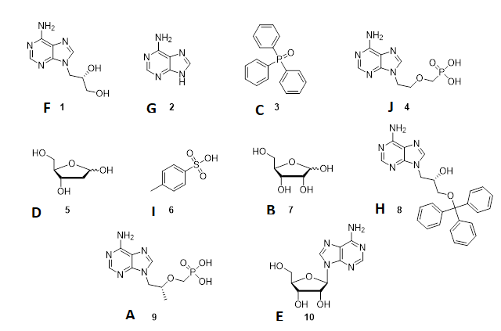
B, D – permanganate, rest UV (hemiacetal OH group is easily oxidised, aromatic systems absorb). 0,2 points for each right answer, 1 point for nice looking TLC, total 5 points
Question C2.2
0,5 point for each well performed TLC, 0,5 point for each rightly calculated Rf (based on students TLC experiment).
R_{f} | A | B | C | D | E | F | G | H | I | J
IPAV | 0,36 | 0,42 | 0,85 | 0,62 | 0,64 | 0,68 | 0,7 | 0,85 | 0,68 | 0,32

Question C2.3
0,5 points for each correctly calculated Rf (according to TLC), 1 point for correct decision of mobile phase – 70% 2-propanol plus 30% ammonia. Total 6 points.
Question C2.4
A | B | C | D | E | F | G | H | I | J
No | Yes | No | Yes | Yes | Yes | No | No | No | No

0,3 points for nice TLCs, 0,5 points for each right answer, total 8 points
Question C2.5
4 points for determining the the tritylated DPHA (H), 4 points for determining the DPHA (F)
1 pt for each well-looking TLC
10 points in total

Task total 39 pts

