Question A5.4 The condition that dramatically changes red blood cell properties in the pathological sample is sickle cell anaemia, a monogenic disease in which the haemoglobin gene is mutated, causing the protein to polymerise when oxygen levels are low. This profoundly changes the shape of the affected cells.
As has been shown in the case of the CCR5 mutation, some mutations could be beneficial under certain conditions, namely under selection shaped by interaction with pathogens or parasites. The geographic distribution of the high prevalence of the sickle cell anaemia mutation generally corresponds with the historical spread of one particular pathogen/parasite (and a corresponding disease). (2 points)
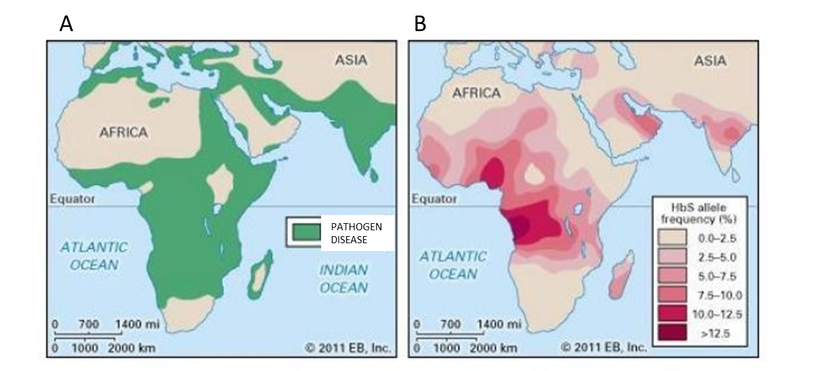

Distribution of which pathogen/parasite is on map A?
- Plasmodium
- HIV I
- Rabies virus
- Ascaris
Distribution of which pathology (disease) is on map A?
- AIDS
- Rabies
- Malaria
- Sleeping sickness
Question A5.5 Which of the following symptoms would the patient with sickle cell anaemia suffer? (1 point)
- Shorter lifespan of erythrocytes linked to lower hematocrit
- Excess of oxygen in peripheral tissues
- Delayed growth and puberty
- Frequent infections due to the fact that the patient’s spleen has to “invest” more space to erythrocyte management than to the production and differentiation of immune cells

Question A5.6 Imagine, that the blood sample of a patient afflicted with sickle cell anaemia you investigated belongs to a patient who is also suffering from AIDS (although stabilised by a long-term treatment with anti-viral therapeutics most probably containing inhibitors developed by Professor Antonín Holý). If the patient didn’t take the anti-HIV drug, which white blood cells would be primarily affected and therefore almost depleted from the blood? (1 point)
- Neutrophils
- Helper T-cells
- B-lymphocytes
- Monocytes

