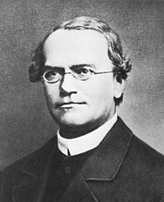
ANSWER SHEET
EOES 2022 – BIOLOGY –PART 2
GREGOR JOHANN MENDEL

TASK 1: (3 points)
Question 1.1 (1 points)
What is the overall frequency of wild-type CCR5 (e.g., “normal”) and mutant CCR5-Δ32 alleles in “Erasmus human population” (which can be assumed to be in Hardy-Weinberg equilibrium)?

Frequency of wild-type CCR5 allele 0,93

Frequency of mutant CCR5-Δ32 allele 0,07

Question 1.2 (1 point)
Which of the following statements A–D can be used as a correct interpretation of the plotted data? Circle it/them.
- There is no statistical correlation between the outcome and severity of SARS-CoV-2 infection and CCR5-Δ32 mutation frequency.
- A stronger protective effect of the CCR5-Δ32 mutation can be seen in the number of deaths compared to the sum of infections.
- The immune system actively contributes to the pathology of COVID-19.
- There is a stronger protective effect of the CCR5-Δ32 mutation on the sum of infections compared to the number of deaths.

Question 1.3 (1 point)
What is the corresponding average frequency of people who suffer from cystic fibrosis in Europe?
2,89x10⁻⁴ 1:2890

TASK 2: (10.5 points) + 4 points for loading and optimal running of electrophoresis –14.5 points total
Question 2.1 (1 point)
Arrange the loading pattern of samples and molecular weight standards according to rational experimental practice. Draw your loading design in the box:

Question 2.2 (1.5 points)
Write the numbers of the corresponding samples in the boxes below.

Dominant homozygote: 3

Heterozygote: 1

Recessive homozygote: 2

Question 2.3 (2 points)
What is the resulting number of amplified molecules if the PCR started from DNA isolated from a single human somatic cell and the reaction conditions were ideal? (write a number)

Dominant homozygote: 2 097 152

Heterozygote (specify the number of dominant/recessive copies): 1 048 576 / 1 048 576

Recessive homozygote: 2 097 152

Question 2.4 (1 point)
The number of nucleotides missing in the CCR5-Δ32 mutation is 32. Which of the following statements A–D) is/are true for the severity of the mutational outcome? (Circle the correct answer/answers).
- The result is shortening of the CCR5 by 8 amino acids and no shift in a reading frame, since human leucocytes use a 4-letter genetic code.
- The result is a shortening of the CCR5 and a shift in a reading frame that typically leads to a premature termination of translation resulting in the substantial shortening of the protein product.
- Shortening of the CCR5 gene leads to a shift in a reading frame that typically leads to inhibition of translation termination, which results in the production of a longer protein.
- Similar severity of the phenotype could be observed in CCR5-Δ1 or CCR5-Δ2 mutation, but not in CCR5-Δ3.
Question 2.5 (1 points)
Which of the two sisters could be potentially resistant to HIV? (Indicate your answer with a tick ✓)

Nana:

Lulu:

None of the two sisters:

Question 2.6 (1.5 point)
Draw a schematic but detailed molecular structure of a nucleotide (including all atoms and chemical bonds), a building block of DNA (containing the distinctive base between DNA and RNA). Sugar part in black, base in green, and phosphate in red. Provide a name using three letter abbreviation code (e.g., ATP).

Question 2.7 (1.5 point)
Draw a schematic but detailed molecular structure of a nucleotide (including all atoms and chemical bonds), a building block of RNA (containing the distinctive base between DNA and RNA). Sugar part in black, base in green, and phosphate in red. Provide a name using three letter abbreviation code (e.g., ATP).

Question 2.8 (1 point)
Circle the difference in the chemical structure of a sugar part of DNA and RNA nucleotides in both drawings using blue pencil.

If you are truly not able to answer questions 2.6–2.8, open the envelope labelled “DNA vs RNA STRUCTURES”. (2 points, instead of total 4 points for 2.6–2.8)
Distinguish the structure formulas of DNA and RNA from each other (indicate this by writing ‘DNA’ or ‘RNA’ in the boxes provided in the Answer sheet. Circle the difference in chemical structure between DNA and RNA in the sugar part in both drawings using a blue pencil.

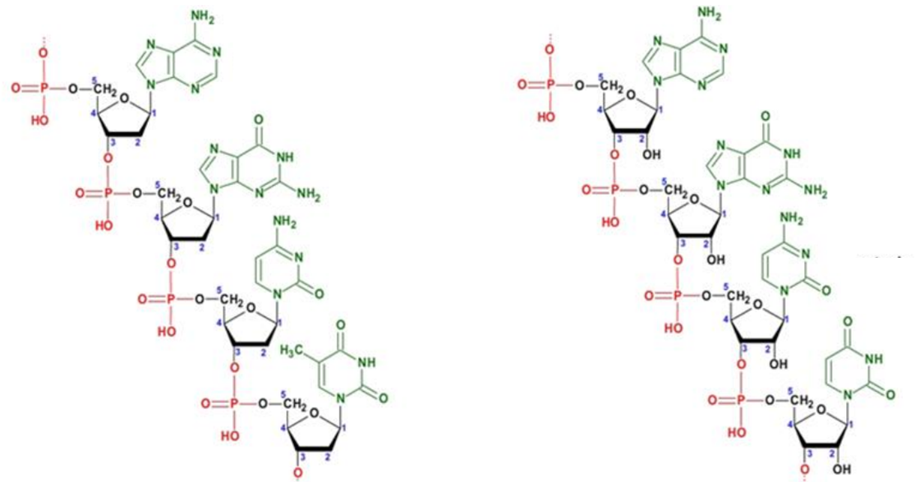

DNA RNA
JAN JANSKÝ
TASK 3: (7 points)
Question 3.1 (1 point)
To which blood group/groups does the depicted sample belong (use a tick ✓ to indicate the right answer/answers)?

A

B

AB

0

Question 3.2 (1 point)
What would be genotype/genotypes for all 4 blood groups? Use A, B, and 0 to denote alleles. If more than one genotype exists, include all possible genotypes. Omit rare alleles of other genes interacting with the AB0 system, such as the h allele responsible for the Bombay phenotype.

A AA, A0

B BB, B0

AB AB

0 00

Question 3.3 (1 point)
Which allele/s is/are codominant? A, B

Which allele/s is/are recessive? 0

Question 3.4 (1 point)
Draw a schematic explanatory figure depicting the role of antibodies in blood group identification for the sample from question 3.1. Red blood cells and antibodies don’t need to be in scale.

Question 3.5 (1 point)
Antibodies (immunoglobulins) are proteins produced by B-lymphocytes (B-cells) during immune response and optimised for high-affinity binding to particular antigens. Which of the pictures A–D corresponds to the 3D conformation of an antibody? Indicate the correct answer with a tick ✓.

A

B

C

D

Question 3.6 (1 point)
During immune response, unique genetic processes are implemented, diversifying the genetic information beyond the one inherited from the parents. Novel variants of genes are formed this way. Which of the following molecular mechanism/s A–D is/are involved? (Circle the right answer/answers).
- Recombination
- Addition (insertion) of new nucleotides
- Deletion of nucleotides
- Use of reverse transcriptase

Question 3.7 (1 point)
Imagine that a plasmatic cell (B-cell producing soluble antibodies specific for a particular antigen in large quantities) is used for animal cloning. What will be the immunological phenotype of the experimental animal? (Circle the right answer/answers).

- There will be no difference.
- The animal will produce only one type of T-cells.
- The animal will be able to produce only one type of antibody specific to one antigen.
- Immunodeficiency.

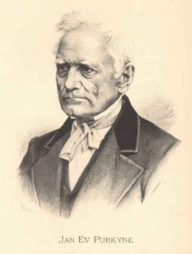
JAN EVANGELISTA PURKYNĚ
TASK 4 (15 points) + 3 points for blood smear specimens – 18 points total
Question 4.1 (3 points)
Draw representative images of all blood smear specimens prepared by yourself (use immersion oil and corresponding 100x magnification objective).

SLIDE 1

SLIDE 2

SLIDE 3

Question 4.2 (1 point)
Identify the blood source of each sample and write the corresponding number of the slide in the proper box:

Mammal blood: 1

Bird blood: 2

Amphibian blood: 3

Question 4.3 (1 point)
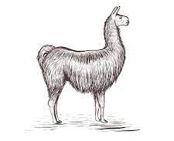
Draw a picture of the mammal to which the mammalian blood smear belongs. The best drawing will be awarded a special price!
Question 4.4 (1 point)
You are provided with statements A–D. Write the corresponding letters of all statements that apply to the slides into the boxes provided. You may use the same statement more than once.
- Erythrocytes contain haemoglobin as an oxygen carrier.
- Erythrocytes constitutively produce proteins.
- Erythrocytes could theoretically undergo oncologic transformation.
- Erythrocytes develop from the precursor cell by mitosis.

Slide 1: A

Slide 2: A, B, C, D

Slide 3: A, B, C, D

Question 4.5 (3 points)
Test the hypothesis that the nucleo-cytosolic ratio is constant in the majority of cases, including red blood cells. Calculate the nucleo-cytosolic (genome-cytosolic) ratios for both cell types (consider the shape of the cells to be an ideal ellipsoid where b=c). Write your result in the boxes provided.

sample 2 974 418

sample 3 963 232

Based on your results, decide whether the hypothesis that the nucleo-cytosolic ratio is constant is true for the red blood cells provided. Circle the right answer.

TRUE/FALSE

Question 4.6 (1 point)
What would be the volume of the lungfish red blood cells? What would be the height and length (length = width, b=c, height is 1,5x longer than length) of the lungfish red blood cells? Use the mean value of the nucleo-cytosolic ratio from your results for samples 2 and 3.
Write your result in the box provided.

36 μm length x width 24 μm

Question 4.7 (1 point)
Draw a side cross section (through the middle of the cell) view of the RBC.

Question 4.8 (1,5 points)
What would be the surface volume ratio for the cells in the sample 2 and 3 and those of lungfish origin? Write your results in the boxes provided.

(SA:V) ratio (slide 2) 0,375

(SA:V) ratio (slide 3) 0,270

(SA:V) ratio (lungfish) 0,112

Question 4.9 (1,5 points)
Taking into account these hallmarks of life/cellularity – erythrocytes from which sample/samples are not alive? Mark the answer with a tick ✓.

Slide 1:

Slide 2:

Slide 3:

TASK 5 (7.5 points)
Question 5.1 (2 points)
Draw representative images of both slides (A and B) under 100x magnification using immersion oil.
SLIDE A

SLIDE B

Question 5.2 (0.5 point)
Which of the two samples (A or B) is pathological? Write your answer in the box.
B

Question 5.3 (1 point)
Which of the following pathologies correspond to the phenotype observed under the microscope? (Circle the right answer.)
- Sickle cell anaemia
- Polycythaemia vera (higher than normal erythrocyte count)
- Anaemia caused by lack of iron
- Leukaemia
- Malaria
- Thalassemia

After answering this question (identifying the pathology), raise your hand. A lab assistant will stamp your answer and provide you with an extra sheet of paper.

Question 5.4 (2 points)
Distribution of which pathogen/parasite is on map A? (Circle the right answer.)
- Plasmodium
- HIV I
- Rabies virus
- Ascaris
Distribution of which pathology (disease) is on map A? (Circle the right answer.)
- AIDS
- Rabies
- Malaria
- Sleeping sickness
Question 5.5 (1 point)
Which of the following symptoms would the patient with sickle cell anaemia suffer? (Circle the right answer/answers.)
- Shorter lifespan of erythrocytes and therefore their quicker turnover
- Excess of oxygen in peripheral tissues
- Blockage of blood flow in capillaries
- Delayed growth and puberty
- Frequent infections due to the fact that the patient’s spleen has to “invest” more space to erythrocyte management than to the production and differentiation of immune cells
Question 5.6 (1 point)
If the patient didn’t take the anti-HIV drug, which white blood cells would be primarily affected and therefore almost depleted from the blood? (Circle the right answer.)
- Neutrophils
- Helper T-cells
- B-lymphocytes
- Monocytes

